**Chapter 6: EXPERIMENTAL RESULTS**

**6.1 Implementation Overview**

The performance of the proposed algorithm is extensively studied on 18 stimulated 3D brain MR image volumes downloaded from the brain-web database having various range of noise and IIH. We have used T1-weighted brain MR image volumes, as this modality is the most commonly used in clinical studies and the ones typically affected by IIH.

The proposed algorithm is implemented in Python Programming language on a computer with Intel Core i5 @ 1.60 GHz CPU and 8GB RAM running on Windows 10.

It takes around 30-40 iterations on a 3D brain MR image volume of the size 181× 217 × 51.

The brain volume is differentiated into four regions (C = 4) or tissue clusters. These four tissue clusters included the three main constituents of the brain. The segmented regions are:

1. Background (BG)

2. Cerebrospinal Fluid (CSF)

3. Gray Matter (GM)

4. White Matter (WM)

The values of the constants are chosen empirically as:

G = 0.4, H = 0.3 and I = 0.3 which follows the constraint that (G + H + I) = 1 and 0 < G, H and I < 1.

The values of P = 1, Q = 4 and R = [3, 4]

The neighborhood window size of 3 × 3 × 3 is also empirically selected and used to computer the mean Euclidean distance of the voxel and the measure of the belongingness factor for the same.

**6.2 Classification Metric**

The investigation is performed by analyzing the performance of the algorithm based on the following metrices. The metrices are listed below and defined in details in the later part of the chapter.

1. Misclassification Error (*MSE*)

2. Average Segmentation Accuracy (*Avg SA*)

3. Dice Coefficient (*DSC*)

4. Partition Coefficient (*Vpc*)

5. Partition Entropy (*Vpe*)

The predicted values are compared and investigated with respected to the ground truth provided by the brain-web database.

**6.2.1 Misclassification Error (MSE)**

This quantity gives us an idea of the instances which were wrongly classified by the algorithm. In this investigation, we have calculated MSE in terms of percentage, going by the formula given below.

Assuming that is the predicted value for the observation, and is the actual value for that observation. Then, MSE in percentage can be calculated as: [29]

The value of MSE% lies in the range of [0 - 100]. In ideal cases, the value of MSE% should be as close to 0 as possible. Getting a value close to 0 signifies that the fewer number of observational values are wrongly classified and the algorithm is robust and efficient.

**6.2.2 Average Segmentation Accuracy (Avg SA)**

The segmentation accuracy (SA) [9, 14] of a clustering algorithm can be defined as the ratio of the number of correctly classified voxels and the actual number of corresponding voxels in the ground truth.

The formula to calculate Average segmentation accuracy is given below:

Let represents the set of the voxels correctly classified by the algorithm into the cluster (distinct region or tissue) and is the set of the voxels present in the ground truth of the cluster.

Then, the SA for the cluster , denoted as is defined by the following equation:

eq (6.1)

And from this Average Segmentation accuracy over all the clusters can be defined as:

eq (6.2)

The range of value of Avg SA is between [0.0 – 1.0]. The algorithm is said to be better if the value of SA is closer to **1.0** and in an ideal case its value is exactly equal to 1.0.

**6.2.3 Dice Similarity Coefficient (DSC)**

Dice similarity coefficient or DSC measures the spatial overlap between the segmentation result and the ground truth. This is an important performance metric.

Let us assume that ***C*** is the total number of clusters, the set of voxels of cluster ***i*** in the segmented image volume is . Similarly, the set of voxels of cluster ***i*** in the ground truth image volume is represented by .

The dice similarity coefficient or Dice Coefficient is defined as follows [11,16]:

eq (6.3)

The value of DSC fall in the range of [0.0 – 1.0] and can be also extended for the range of [0.0 – 100.0] by multiplying the value obtained with 100. The algorithm is said to be better if the value of DSC is close to the value of 1.0. In an ideal case, the value of DSC is exactly 1.0.

**6.2.4 Partition Coefficient (Vpc)**

The above three metrics are depended on the value of the ground truth provided. In the absence of a ground truth, it is better to have some metric that can measure the efficiency of the algorithm.

Partition entropy ***Vpc*** is an important index under the clustering validity functions. It measures the confidence of the algorithm while classifying the patterns (here the voxels).

The equation to calculate the partition Coefficient is given below [6, 11, 16]:

eq (6.4)

The value of ***Vpc*** falls in the range of [0.0 – 1.0]. A higher value of ***Vpc*** is considered to be good because it shows the higher amount of confidence that the algorithm has in its classification.   
In an ideal case, the value of ***Vpc*** should be equal to 1.0.

***Partition Entropy (Vpe)***

Partition Entropy is yet another important index under the clustering validity functions. It measures the uncertainty while classifying the voxels into its correct clusters and negating into another clusters.

The equation to calculate the Partition Entropy is given below [6, 11, 16]:

eq (6.5)

The value of ***Vpe*** falls in the range of [0.0 – 1.0]. A lower value of ***Vpe*** is considered to be good because it shows that the algorithm is less uncertain while classifying the voxels into its constituent categories. In an ideal case, the value of ***Vpe*** should be equal to 0.0.

**6.3 Quantitative analysis Results**

The performance of the algorithm depends on the values of the parameters of P, Q and R. This section presents a performance analysis by varying the combination of the values of P, Q and R over different 3D image volumes.

**6.3.1 Misclassification Error**

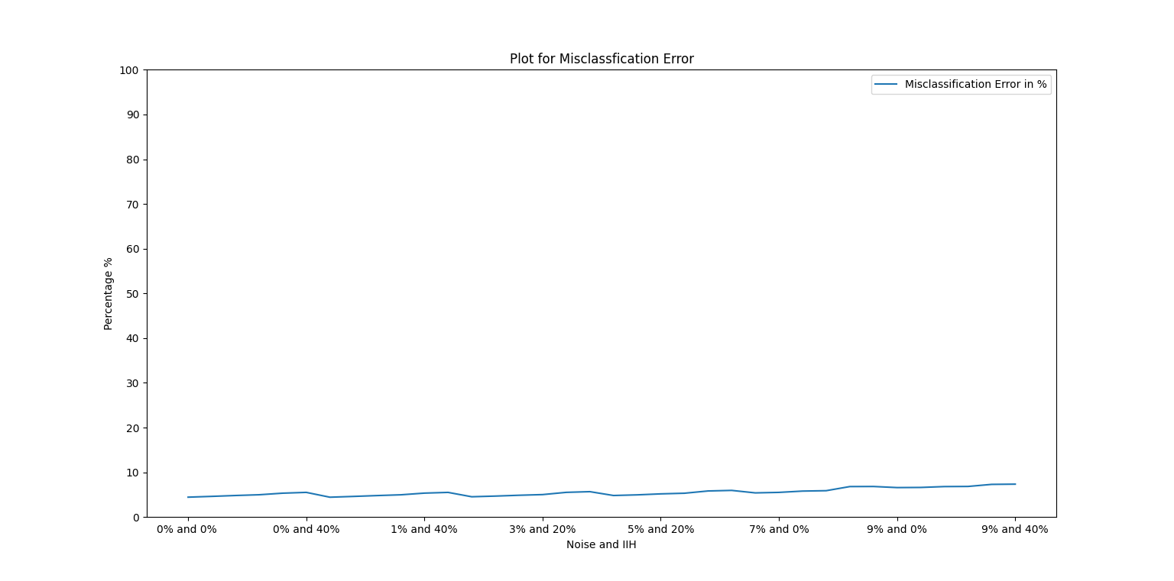

Figure 6.1**: Plot for Misclassification Errors**

Figure shows the plotting of Misclassification error in terms of percentage over various 3D image volumes containing different amount of Noise and IIH. It is noticeable that the level of the MSE% is almost constant and under the range of 0-7%.

**6.3.2 Dice Similarity Coefficient**

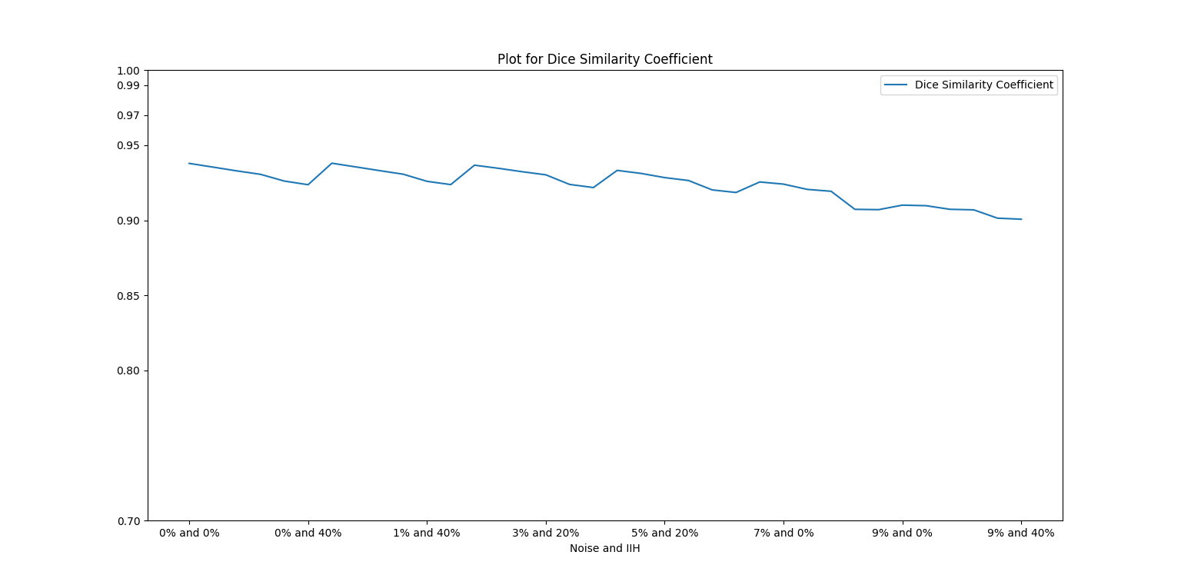

Figure 6.2**: Plot for Dice Similarity Coefficient**

Figure shows the plotting of Dice Similarity Coefficient of various 3D image volumes containing different amount of noise and IIH. It is noticeable that the level of DSE is almost constant and has a high value in the range of [0.9 – 0.95], which is considered to be a good metric for a classification algorithm.

**6.3.3 Segmentation accuracies of various tissue region**

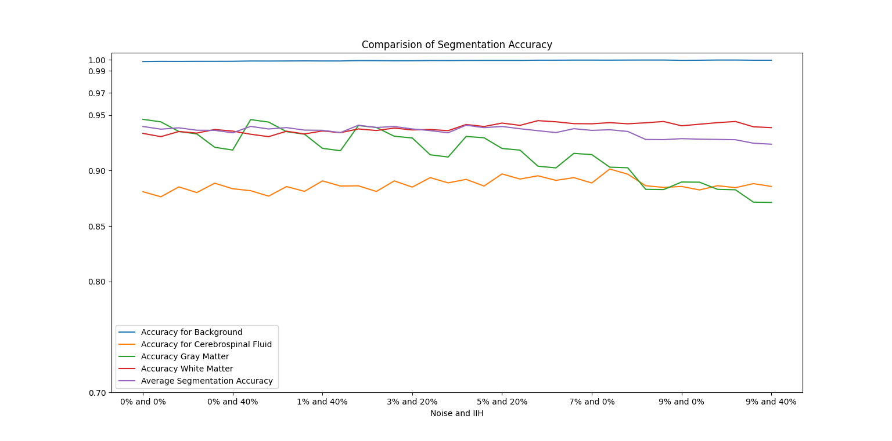 Figure 6.3**: Comparison plot for segmentation accuracies across tissue region and average segmentation accuracy.**

In this algorithm, we have segmented the 3D brain MR image into 4 clusters namely, Background (BG), Cerebrospinal Fluid (CSF), Gray Matter (GM) and White Matter (WM).

We have calculated the segmentation accuracy for each of the tissue region and plotted them in the same graph to give a comparative idea of their accuracy across all the clusters. We have also calculated the average segmentation accuracy of the algorithm and plotted it in the same graph.

Segmentation Accuracy for the background is plotted in Blue, which is in the range of 0.99 – 1.00 that translates to 99% to 100% accuracy. Segmentation Accuracy for cerebrospinal fluid is plotted in Orange, which is in the range of 0.87 – 0.91 that translates to 87% to 90% accuracy. Segmentation Accuracy for Gray Matter is plotted in Green, which is in the range of 0.93 – 0.95 that translates to 93% to 95% accuracy. Segmentation accuracy for White matter is plotted in red, which is in the range of 0.94-0.97 that translates to 94% to 97% Segmentation accuracy.

The average accuracy is plotted in Blue, which is in the range of 0.93-0.95, which translates to 93% to 95% accuracy across all the clusters.

***Plot for Partition Coefficient and Partition Entropy***

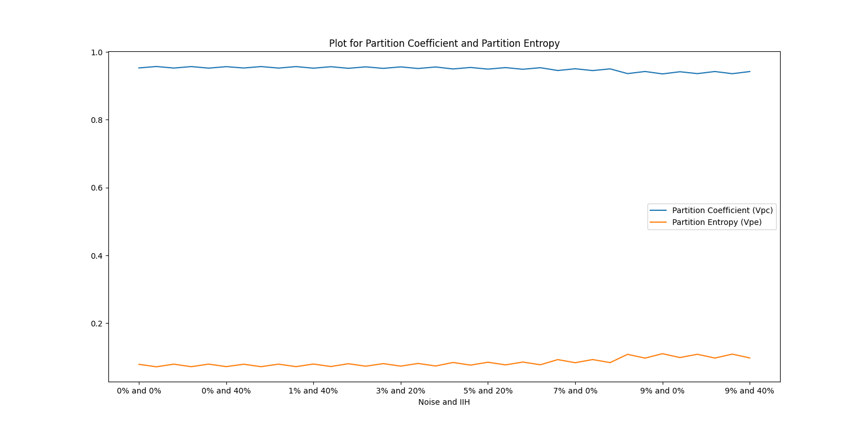 Figure 6.4**: Comparison plot for Partition Coefficient (Vpc) and Partition Entropy (Vpe)**

Figure shows the plotting of Partition Coefficient and Partition Entropy in the same graph.

***Partition Coefficient (Vpc)*** is plotted in Blue, which is almost stable in the range of 0.94 to 0.95. A high value of Partition Coefficient (Vpc) is considered to be a good metric for a classification algorithm as it shows that the algorithm has higher confidence in its classification.

***Partition Entropy (Vpe)*** is plotted in Orange, which is almost stable in the range of 0.05 – 0.1. A low value of Partition Entropy (Vpe) is considered to be a good metric for a classification algorithm as it shows that the algorithm is very less uncertain in its classification.

**6.4 Qualitative Analysis Results**

We have downloaded the simulated brain MR image volumes from the BrainWeb by varying the amount of noise (0% to 9%) and IIH (0% to 40%). Each image volume is of size (height x width x depth) 181 x 217 x 181 with voxel thickness of 1 mm x 1 mm x 1mm.

Among the 18 image volumes, a T1-weighted simulated 3D brain MR image volume, having 9% noise and 40% IIH (maximum amount of noise and IIH), consisting of 51 images or slices (slices 50 – 100 are considered as they have fair amount of CSF, GM and WM regions) from BrainWeb. We have shown the results of one of the slices from the 3D image volume.

Figure 6.5 **Comparison of the segmented Images**

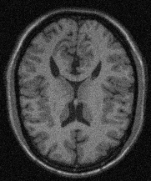

Unsegmented (Image Slice 85)



Gray Matter (Image Slice 85)



Cerebrospinal Fluid (Image Slice 85)



White Matter (Image Slice 85)